ANALYSIS OF ETHICS EDUCATION IN SCIENCE AND TECHNOLOGY:

FINDINGS OF THE ACADEMIC SURVEY

Contents
- Introduction
- Expected skills and degree of their acquisition
  - Undergraduate level
  - Graduate level
  - Discrepancy between expected and acquired skills in ethics education
- Problems and difficulties of ethics courses
    - Problems and difficulties of ethics courses (undergraduate level)
    - Problems and difficulties of ethics course (graduate level)
- Causes or background conditions of the problems and difficulties:
- Teaching methods
    - Teaching methods (undergraduate level
    - Teaching methods (graduate level)
- Technology course: necessary topics

- Introduction

The second work package of the ETHICS4CHALLENGES project focused on identifying systemic problems, gaps and needs, alongside successful practices within both academic and non-academic sectors regarding ethics education of science and technology.

This document details a critical phase of the identification process, building upon previous foundational stages that included a state-of-the-art analysis of educational practices, focus groups and expert interviews.

Presented here is a graphical representation of findings from the online survey implemented within academia. Each section analyzes specific elements of ethics education, providing an overview of the current needs and gaps.

A total of 80 responses were collected from representatives of higher education institutions across Europe. Participating countries included Austria, Belgium, Denmark, Estonia, France, Germany, Greece, Italy, the Netherlands, Portugal, Türkiye, and the United Kingdom. The survey instrument utilized for this data collection is accessible via the following link: Ethics4Challenges Academic Survey

- Expected Skills and Degree of Their Acquisition

  - Undergraduate Level
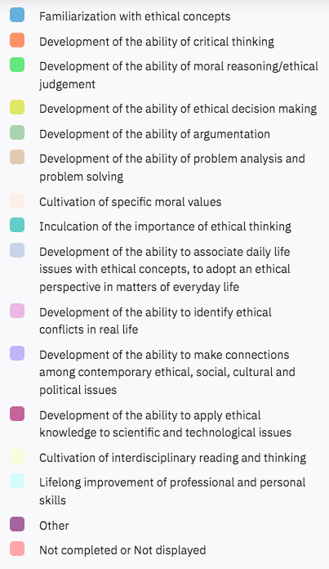
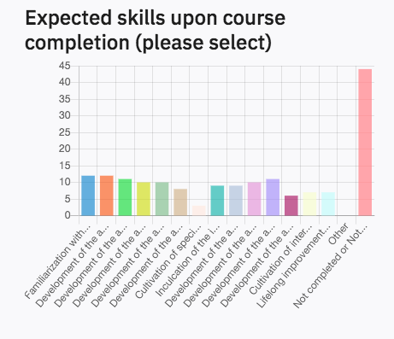

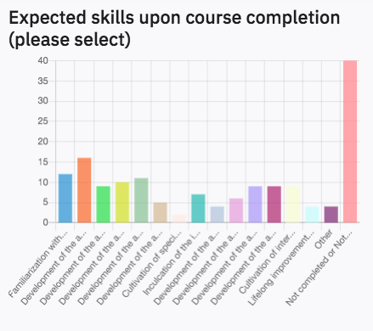
  - Graduate Level

  - Discrepancy Between Expected and Acquired Skills in Ethics Education

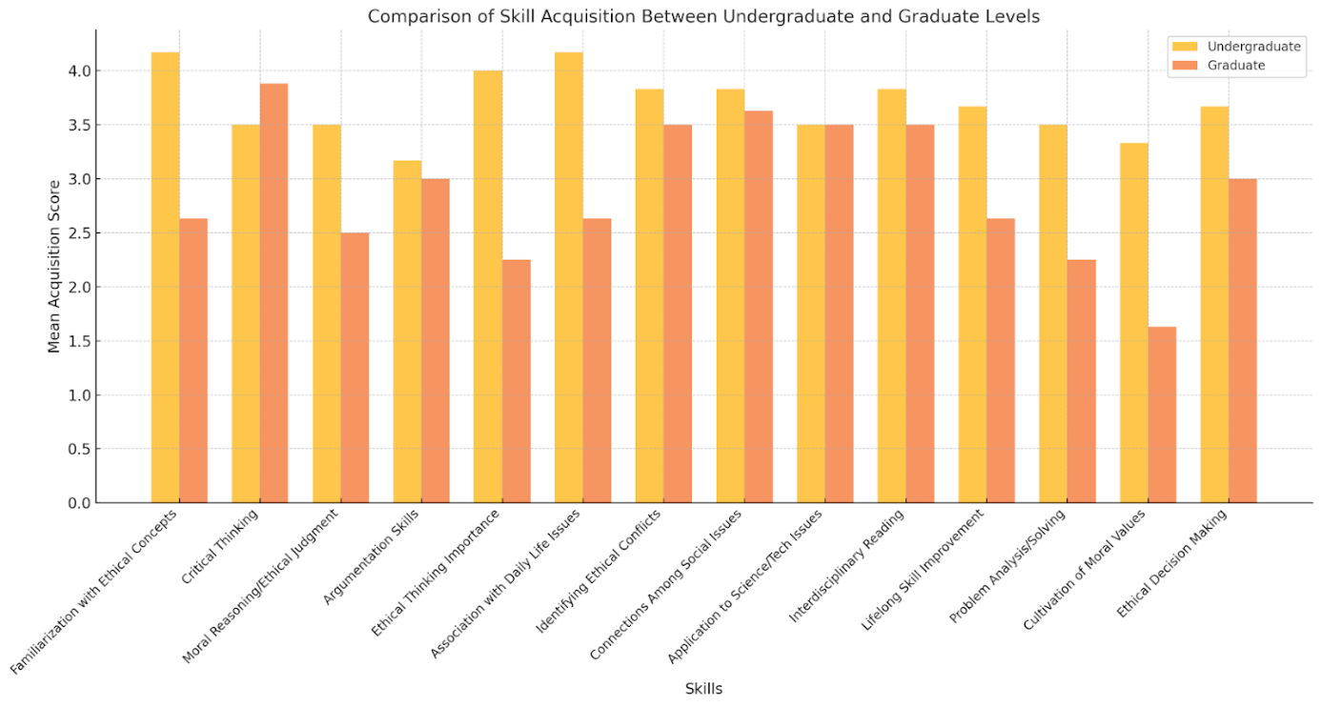
Level of Study | Skill Group | Specific Skills | Expectation Level | Acquisition Level | Discrepancy
Undergraduate | General Theoretical and Ethical Skills | - Critical thinking- Argumentation- Familiarization with ethical concepts- Ethical judgment and decision-making | High | Moderate to Low | Noticeable gap
Undergraduate | Contextual Application Skills | - Relating ethics to concrete situations- Embedding ethics in sociopolitical and cultural contexts | High | High | Largely aligned
Graduate | General Theoretical and Ethical Skills | - Critical thinking- Argumentation- Familiarization with ethical concepts- Ethical judgment and decision-making | High | High | Minimal discrepancy
Graduate | Contextual Application Skills | - Relating ethics to concrete situations- Embedding ethics in sociopolitical and cultural contexts | High | High | Aligned
Graduate | Advanced and Interdisciplinary Skills | - Ethics of science and technology- Interdisciplinary approaches to ethical issues | High | High | Aligned

- Problems and Difficulties of Ethics Courses

  - Problems and difficulties of ethics courses (undergraduate level)
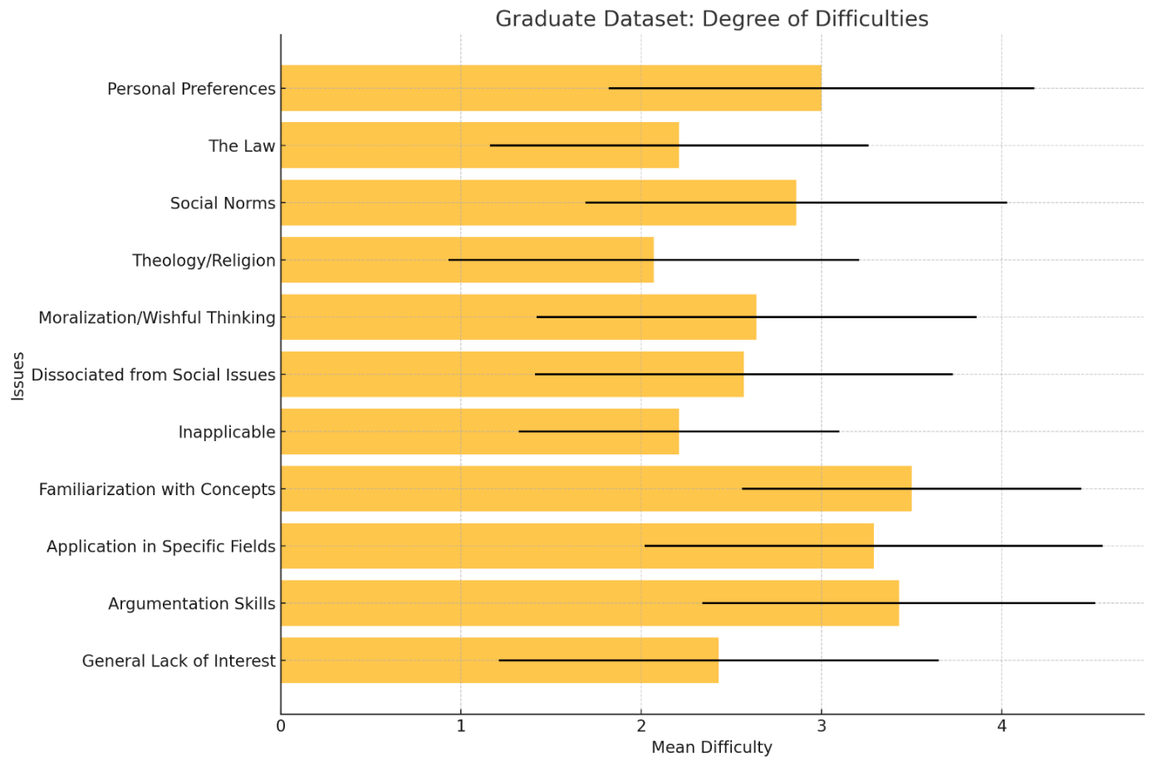

  - Problems and difficulties of ethics course (graduate level)

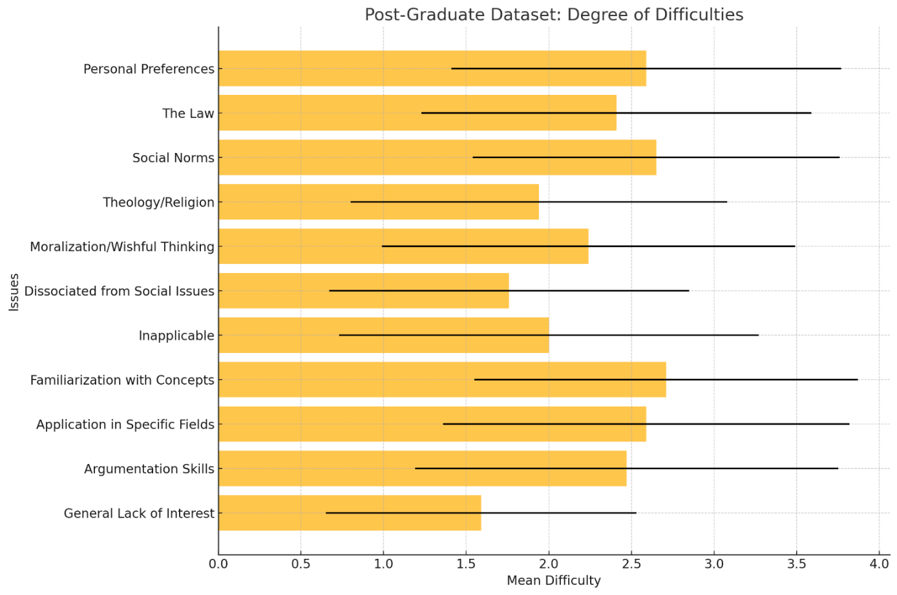

- Causes or Background Conditions of the Problems and Difficulties: Analysis and Recommendations
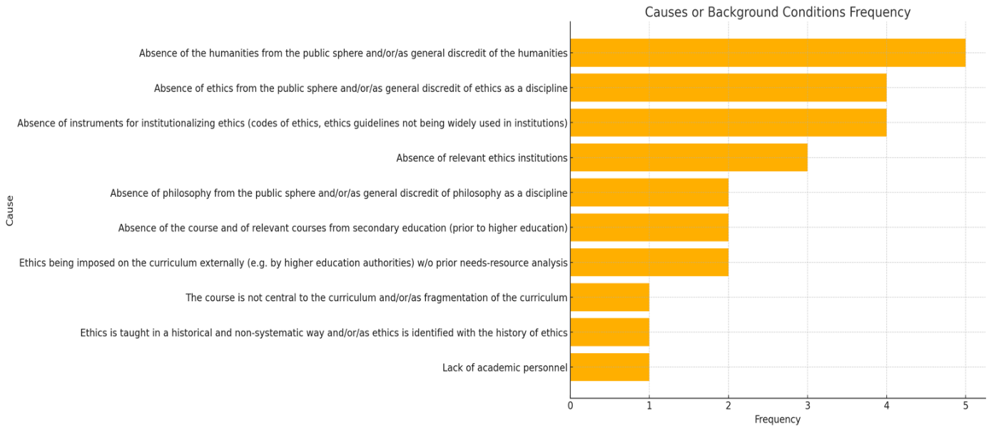
- Teaching methods

  - Teaching methods (undergraduate level)
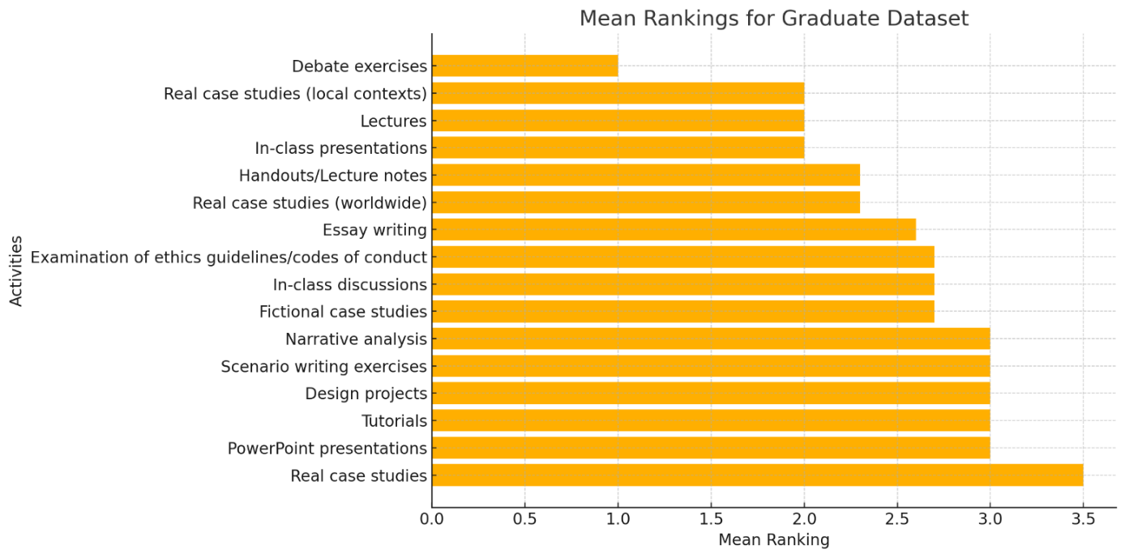

  - Teaching Methods (Graduate Level)
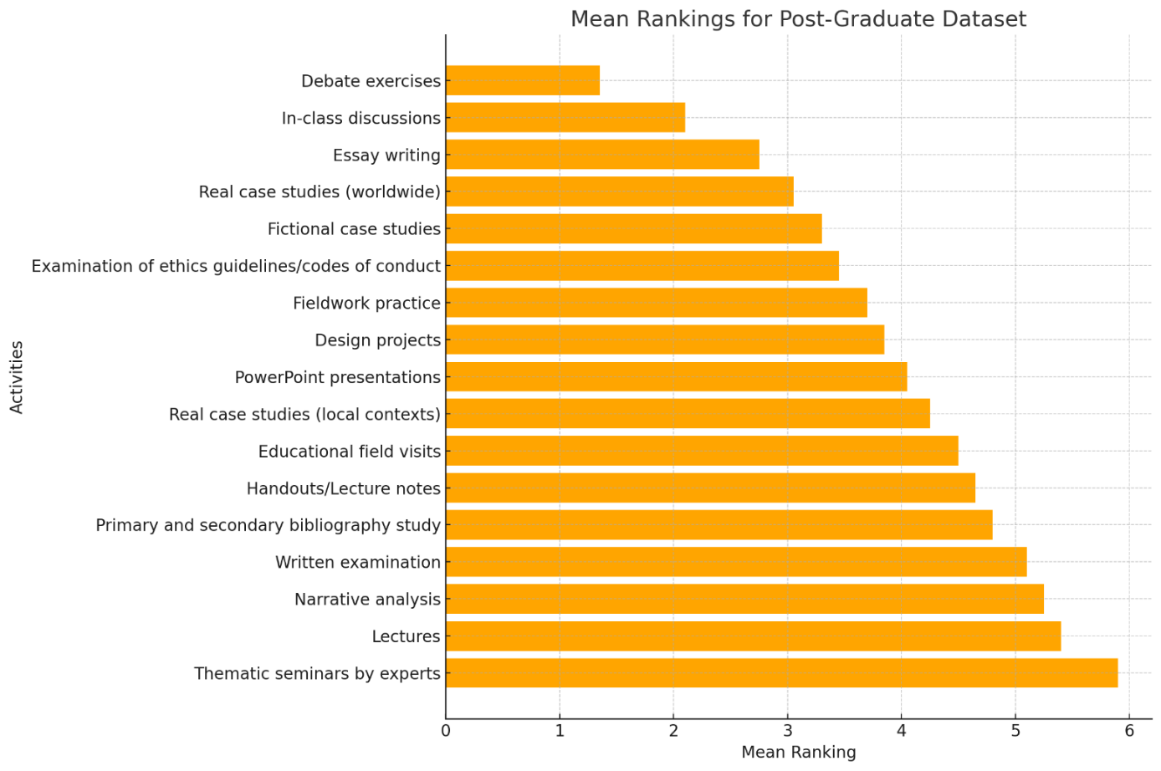
- Technology course: necessary topics

TOPICS CONSIDERED NECESSARY IN A TECHNOLOGY ETHICS COURSE
Rank | Topic | Category | Yes (n) | Yes (%) | Interpretive note
1 | Philosophy of technology | Foundational theory | 34 | 72.30% | Core conceptual framework
2 | Artificial intelligence ethics | Emerging technology | 30 | 63.80% | Key contemporary field
3 | Social impacts of technology | Societal analysis | 28 | 59.60% | Broad socio-technical perspective
4 | Classical ethical theories | Foundational theory | 27 | 57.40% | Normative foundations
5 | Environmental impacts of technology | Sustainability | 23 | 48.90% | Ecological dimension
6 | Engineering ethics | Professional practice | 22 | 46.80% | Core professional responsibility
6 | Big data ethics | Digital technology | 22 | 46.80% | Data governance concerns
6 | Biotechnology and ethics | Applied domain | 22 | 46.80% | Life-science technologies
9 | Gender and technology | Social justice | 21 | 44.70% | Critical perspective
10 | Biomedical ethics | Applied domain | 20 | 42.60% | Clinical and research contexts
10 | Socially responsible design and innovation | Design ethics | 20 | 42.60% | Practice-oriented approaches
12 | Healthcare ethics | Applied domain | 19 | 40.40% | Medical systems and care
13 | Diversity and inclusion | Social justice | 18 | 38.30% | Equity considerations
14 | Corporate social responsibility | Organizational ethics | 17 | 36.20% | Institutional responsibility
15 | Social media ethics | Digital technology | 16 | 34.00% | Platform-based issues
16 | Robot ethics | Emerging technology | 15 | 31.90% | Autonomous systems
17 | Agriculture and food ethics | Applied domain | 7 | 14.90% | Sector-specific topic

MOST FREQUENTLY SELECTED THEMATIC CLUSTERS
Cluster | Topics included | Avg. selection rate
Foundational theory | Philosophy of technology, Classical ethics | 64.90%
Social and justice perspectives | Social impacts,  Gender,  Diversity | 47.50%
Emerging digital tech | AI, Big data,  Social media,  Robotics | 44.10%
Applied bio/health domains | Biomedical,  Healthcare,  Biotechnology | 43.30%
Professional/design practice | Engineering ethics,  Responsible design,  CSR | 41.90%
