GAP ANALYSIS AND
RECOMMENDATIONS REPORT

Contents
Introduction 2
Part 1: Gaps and Recommendations Concerning Academic Sector 3
1. Expected skills and degree of their acquisition 4
1.1. Undergraduate level 4
1.2. Graduate level 5
1.3. Degree to which the expected skills are acquired (comparative table) 6
1.4. Analysis and recommendations 6
2. Problems and difficulties of ethics courses 8
2.1. Problems and difficulties of ethics courses (undergraduate level) 8
2.2. Problems and difficulties of ethics course (graduate level) 9
2.3. Analysis and recommendations 9
3. Causes or background conditions of the problems and difficulties: analysis and recommendations 10
4. Teaching methods 11
4.1. Teaching methods (undergraduate level) 11
4.2. Teaching methods (graduate level) 12
4.3. Analysis and recommendations 12
5. Technology course: necessary topics 13
Part 2: Gaps and Recommendations Concerning Non-Academic Sector 15
1. Overview of the survey 15
2. Background: ethical issues at professional life 19
3. Ethics education in higher education and ethics training in professional life 21
4. Ethics training needs in the technology sector 26
5. Ethics training: necessary topics 29

Introduction
The main goal of the ETHICS4CHALLENGES project is the formation of the appropriate and—as our analyses so far indicate—much needed ethics education, in both the academic and non-academic sector, for addressing the three main current existential threats and challenges, constitutively coextensive with technological civilization:
- New digital technologies: AI, algorithms and Big Data
- Biomedicine and biotechnology
- Environmental and climate crisis

To that effect the project follows a two-pronged approach.
- The first is a diagnostic approach:
  - This approach consists in the identification of the problems, gaps and needs as well as the best practices used in the academic and non-academic sectors regarding ethics of technology and science.
  - Thus, the tools that have so far been implemented to identify the aforementioned lacks, include analysis of the state-of-the-art educational practices, focus groups, interviews, and an expanding online survey.
- The second is a therapeutic approach:
  - This approach consists in the creation of online flexible education pathways to be used by university lecturers, students, researchers, government institutions and technology companies without the need for expert knowledge in technology studies, that address the aforementioned problems, gaps and needs.

In light of the above, this report provides a concluding presentation of the findings of the diagnostic approach. It mainly focuses on and analyses the findings of the two expanding online surveys, which have been grounded in and informed by the previously conducted focus groups and interviews, while, at the same time, drawing upon the insights mined out of them. The first survey was implemented in the higher education sector, addressing mainly universities among other types of higher education institutions. The findings of the first survey constitute the first part of this report. The second survey was implemented in the non-academic sector, addressing mainly technology companies. The findings of the second survey constitute the second part of this report. Each part derives from an analysis of specific elements related to ethics education and training respectively, thus providing an overview of existing needs and gaps in these sectors.

Part 1: Gaps and Recommendations Concerning Academic Sector
This part has five distinct sections. First, we present the ‘expected skills’ of ethics courses (1). More specifically, in this very ‘expected skills’ context, we present the skills the course instructors desire to be cultivated in both undergraduate and graduate levels (1.1–1.2). These results depict the specific goals of an ethics course, and, as such, they can be considered a working reference point, a provisional benchmark. We then supplement a depiction of the degree to which these skills are reported to have been acquired upon the completion of the course, again in both undergraduate and graduate levels (1.3). Thus, any possible discrepancies between the two adumbrate an educational gap we intend to address. We conclude this section with an analysis of these findings for both undergraduate and graduate levels, followed by specific recommendations for each level (1.4).
Second, we present the problems and difficulties regarding ethics courses that have been explicitly reported by instructors in both undergraduate and graduate levels (2.1–2.2), followed again by specific analysis and recommendations (2.3).
Third, we move to a more general but fundamental level, and trace the—also explicitly stated by the instructors—causes and background conditions of the above problems and difficulties (3).
Fourth, we present the teaching methods and analyse their respective efficiency (4), and, finally, fifth, we conclude with the presentation of the reported topics of a technology ethics course that instructors deem necessary (5). Thus, the fivefold structure we offer provides a more comprehensive image of the existing lacks.

1. Expected skills and degree of their acquisition

1.1. Undergraduate level
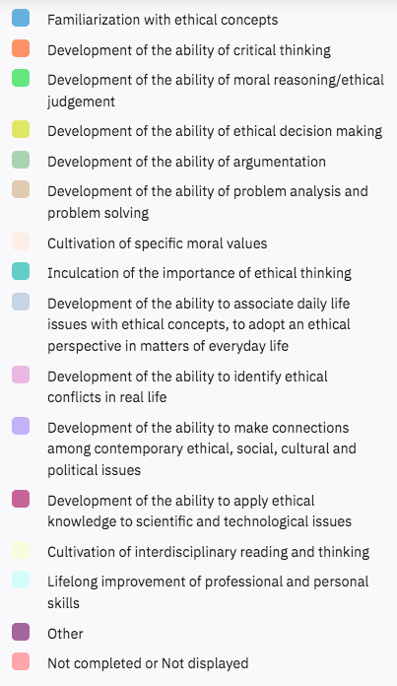
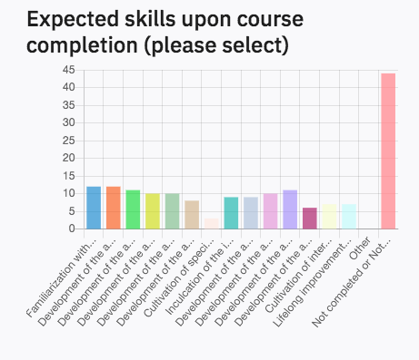

Figure 1.1: Expected skills upon course completion (Undergraduate level)

1.2. Graduate level
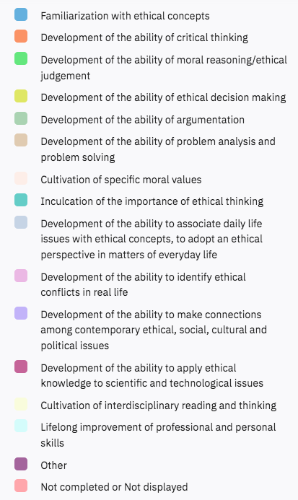
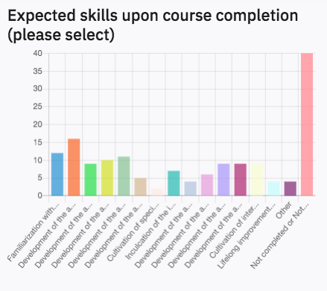

Figure 1.2: Expected skills upon course completion (Graduate level)

1.3. Degree to which the expected skills are acquired (comparative table)
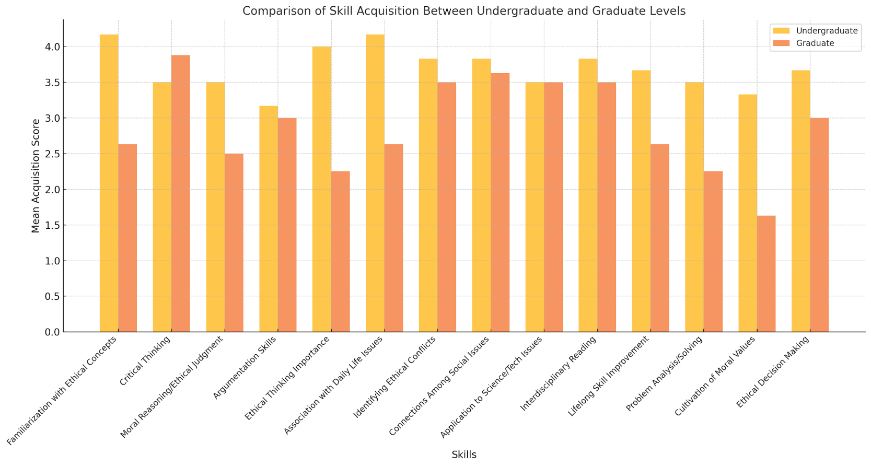

Figure 1.3: Degree to which these expected skills are acquired

1.4. Analysis and recommendations
At the level of undergraduate studies, we observe two groups of expected skills to score high. The first group consists of more general skills, both theoretical (critical thinking and argumentation) and ethically specific ones (familiarization with ethical concepts, and ability of ethical judgment and decision making). The second group consists of skills that enable ethical issues to be related to concrete situations and to be associated with the wider social and political context in which they are embedded. It is reported that the skills of this second group seem to be largely acquired, while a lag is observed in some of the general skills, especially the ones of critical thinking and argumentation.

Level of Study | Skill Group | Specific Skills | Expectation Level | Acquisition Level | Discrepancy
Undergraduate | General Theoretical and Ethical Skills | - Critical thinking- Argumentation- Familiarization with ethical concepts- Ethical judgment and decision-making | High | Moderate to Low | Noticeable gap
Undergraduate | Contextual Application Skills | - Relating ethics to concrete situations- Embedding ethics in sociopolitical and cultural contexts | High | High | Largely aligned
Graduate | General Theoretical and Ethical Skills | - Critical thinking- Argumentation- Familiarization with ethical concepts- Ethical judgment and decision-making | High | High | Minimal discrepancy
Graduate | Contextual Application Skills | - Relating ethics to concrete situations- Embedding ethics in sociopolitical and cultural contexts | High | High | Aligned
Graduate | Advanced and Interdisciplinary Skills | - Ethics of science and technology- Interdisciplinary approaches to ethical issues | High | High | Aligned
Table 1.1: Discrepancy between expected and acquired skills in ethics education

Thus, the educational flexible pathways to be developed for an undergraduate level would need to have an equally twofold content. Namely, the investigation of specific ethical dilemmas and problems needs to be embedded into concrete, everyday sociopolitical and cultural contexts.
At the level of graduate studies, the aforementioned first group of expected skills scores almost equally high compared to the results regarding the undergraduate level. Namely, regarding the first group—that is, the one that consists of more general skills, both theoretical and ethically specific ones—the skills of critical thinking, familiarization with ethical concepts, and general argumentation—are the ones that instructors seem to intend to inculcate more to their students. Regarding the second group of skills, the association of ethical issues with the wider social and political contexts scores equally high compared to the results of the undergraduate level. However, two skills are added to this group: the cultivation of ethics of science and technology, and the cultivation of interdisciplinary approaches for the tackling of ethical issues. It is reported that the skills of both groups seem to be largely acquired.
Thus, the educational flexible pathways to be developed for graduate level studies need to have the following components: (a) First, as it is the case at the undergraduate level, the investigation of specific ethical dilemmas and problems needs to involve the everyday sociopolitical and cultural contexts within which these dilemmas and problems are embedded. (b) Second, the need for an ethics education on science and technology is corroborated, and, in light of these two points, a specific suggestion can be formulated. Namely, ethics of technology in the three fields identified (AI ethics, bioethics and environmental ethics) should combine the standard, foundational readings of each field with approaches that involve contextual and empirical inputs, such as STS, postphenomenology, and ethics in design approaches.

2. Problems and difficulties of ethics courses

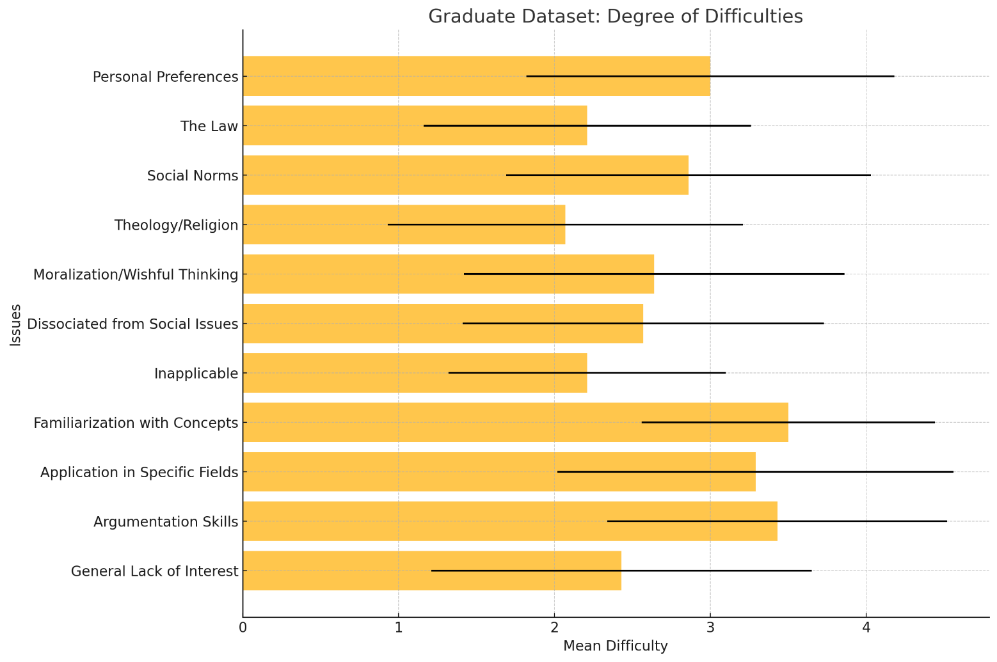
2.1. Problems and difficulties of ethics courses (undergraduate level)

Figure 1.4: Degree of problems and difficulties regarding the teaching of the course (undergraduate level)

2.2. Problems and difficulties of ethics course (graduate level)
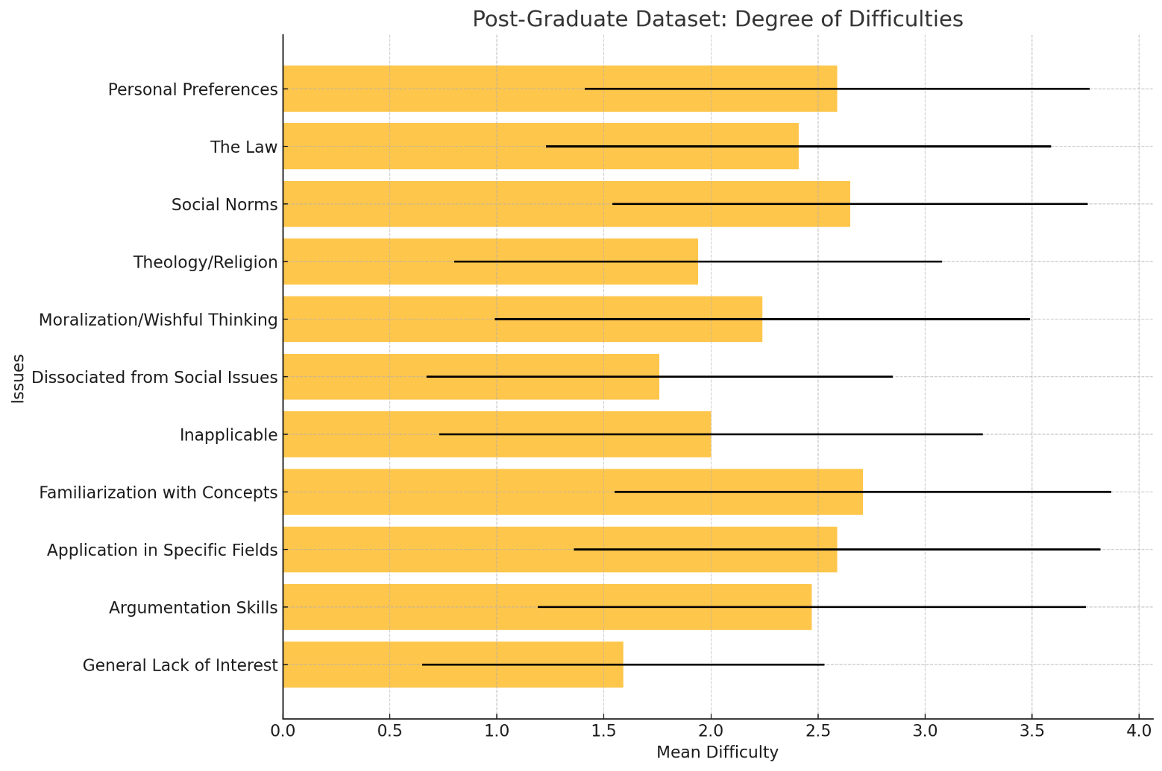
Figure 1.5: Degree of problems and difficulties regarding the teaching of the course (undergraduate level)

2.3. Analysis and recommendations
The identification of problems and difficulties of ethics courses at both undergraduate and graduate levels of study is highly similar. The problems and difficulties of ethics courses that were assessed with the highest degree of importance are five, and can be classified into two main categories. The first category concerns a rather metaphilosophical issue; that is, the acknowledgement of the autonomy of moral philosophy as a discipline. Namely, ethics is identified either with personal preferences, or with social norms, customs, or other entrenched social practices. This means that ethics becomes reduced into either subjective opinion—something that precludes the possibility of rational discussion almost a priori—or sociological, anthropological, or other empirical inquiry, respectively. In either case, moral philosophy is not recognised as an autonomous discipline of epistemic value with an independent normative core and a relatively distinct methodology. The second category of problems and difficulties constitutes a corollary of the first one, as ethics instructors identify a cluster of associated lacks. Namely, they observe the lack of general familiarization with relevant ideas and concepts (such as value, norm, or principle), the lack of familiarization with relevant ideas and concepts in the specific field ethics is applied, and the lack of moral reasoning skills, of argumentation skills in the field of ethics.
This diagnosis seems to be aligned with the aforementioned findings regarding the expected skills and the degree of their acquisition, and, thus, to corroborate and orientate towards a similar set of recommendations. Thus, the educational flexible pathways to be developed for both levels of study would need to be twofold. Namely, the ethics of technology (AI ethics, bioethics and environmental ethics) to be developed should not be identified with the specific technologies to which it is applied.
the educational flexible pathways to be developed for an undergraduate level would need to have an equally twofold content. Namely, the investigation of specific ethical dilemmas and problems needs to be embedded into concrete, everyday sociopolitical and cultural contexts.

3. Causes or background conditions of the problems and difficulties: analysis and recommendations
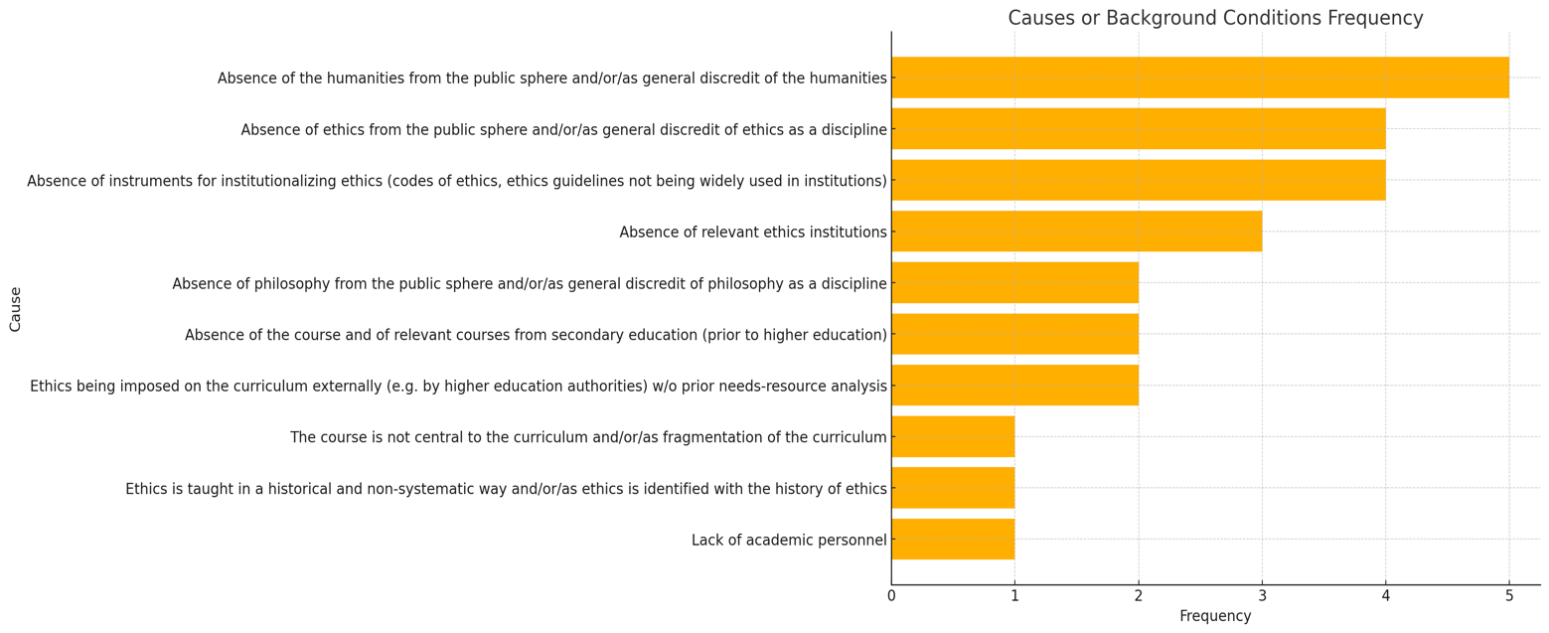

Figure 1.6: Causes or background conditions of the above problems and difficulties

The reported causes or background conditions of the aforementioned problems and difficulties can be categorized into three groups. First, the most commonly cited problem is the absence or discredit of the humanities and of ethics from the public sphere, something that suggests a foundational issue in societal perception. The responses of the second group highlight the lack of institutional tools and absence of philosophy, emphasizing structural gaps. These include issues such as the absence of courses in secondary education, curricular fragmentation, and interdisciplinary gaps. These are less fundamental but still important barriers.
The ETHICS4CHALLENGES project can play a pivotal role to this issue. First, by providing flexible education pathways to both academic and non-academic sectors, the project adopts a grassroots approach across the board which enables the change of the existing public perception regarding both humanities and, especially, ethics. Second, by identifying specific lacks of the existing curricula regarding ethics, the project addresses the issue of the fragmented curricula and counterbalances the absence of ethics as a central component.

4. Teaching methods

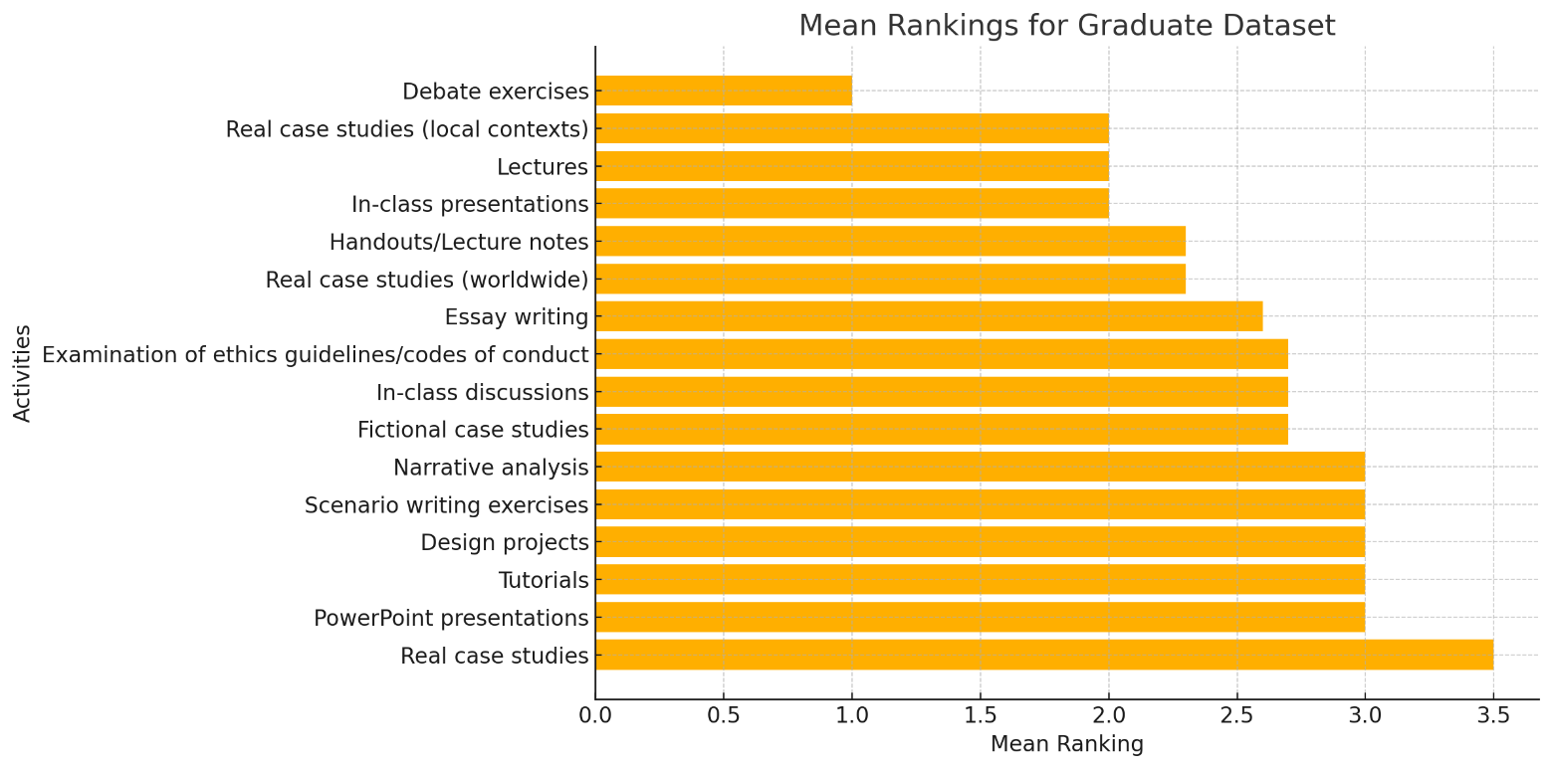
4.1. Teaching methods (undergraduate level)

Figure 1.7: In the context of the ethics course / component you taught, how useful did you find the teaching practices listed below? Please rank 2 to 5 reasons (highest rank meaning more important issue)

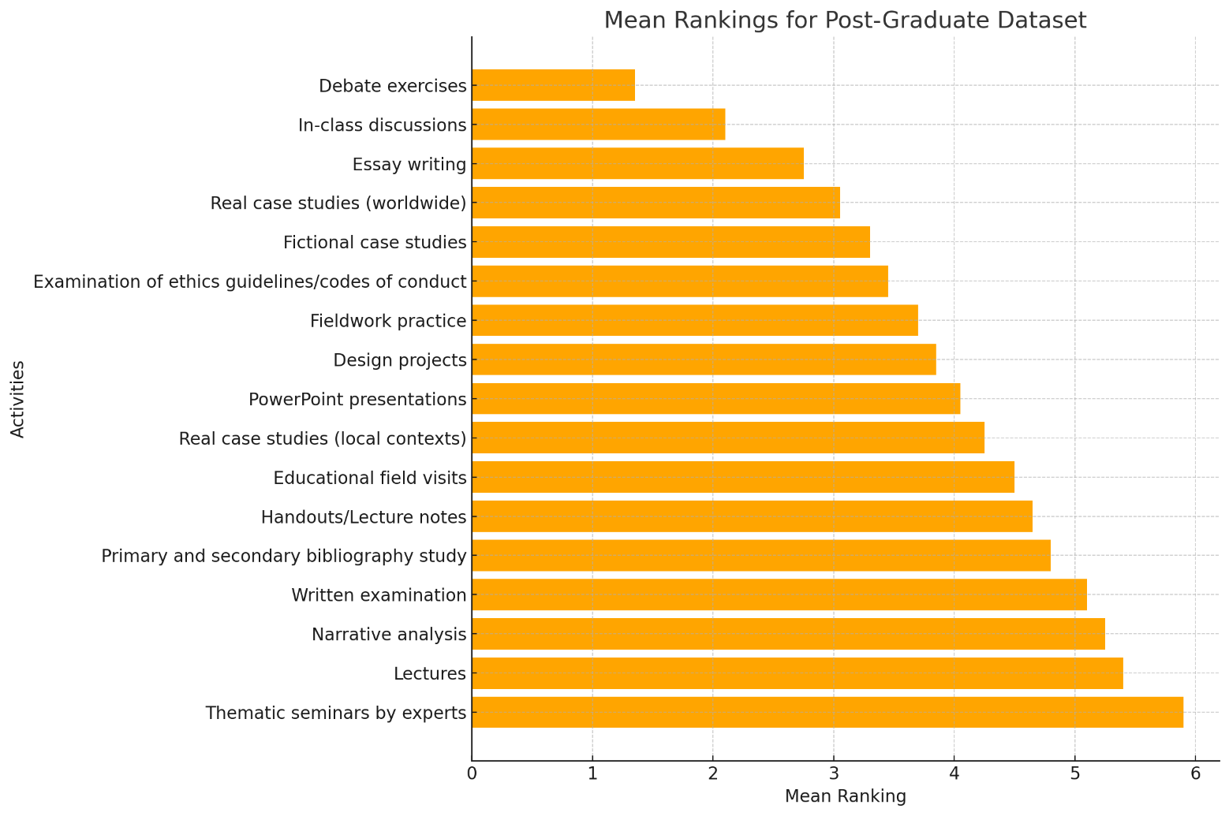
4.2. Teaching methods (graduate level)
Figure 1.8: In the context of the ethics course / component you taught, how useful did you find the teaching practices listed below? Please rank 2 to 5 reasons (highest rank meaning more important issue)

4.3. Analysis and recommendations
On average, regarding the effectiveness of teaching methods in both undergraduate and graduate studies, the teaching method of real case studies acquires a relatively high ranking. Regarding the undergraduate studies level in particular, the specific teaching method scores very high, being the most popular by far. The next group of responses that score high (fictional case studies, narrative analysis, scenario writing exercises, and projects) corroborates strongly the need for concrete analyses. Regarding the graduate studies level, this element of concreteness is still highly registered (real case studies in local contexts, educational field visits, thematic seminars by experts). Specifically, the latter (thematic seminars by experts) is clearly the most popular response. Moreover, in this context of graduate studies, the traditional methods of lectures and of primary and secondary bibliography examination are reported as constitutive to the teaching of ethics.
This diagnosis seems to be equally aligned with the previous findings. The educational flexible pathways to be developed for both graduate and undergraduate studies seem to need the following two core components: (a) case studies, and (b) introductory and accessible bibliographical material for the ethics of specific technological areas (e.g. AI ethics, bioethics and environmental ethics).

5. Technology course: necessary topics
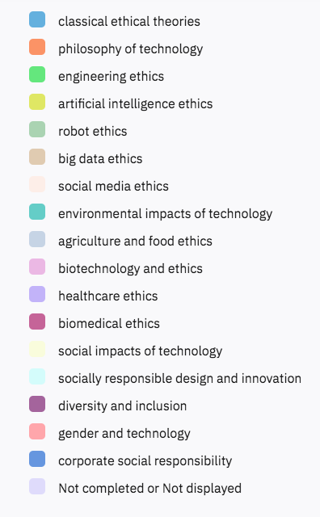
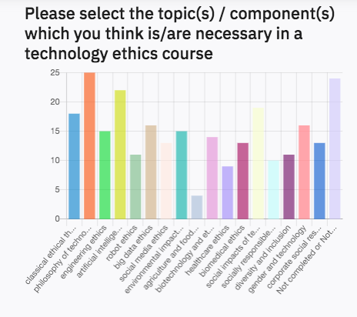

Figure 1.9: Please select the topic(s) / component(s) which you think is/are necessary in a technology ethics course

The reports regarding the necessary topics and components for a technology ethics course substantiate and corroborate the previous recommendations. Namely, according to the highest scores recorded:
- Technology ethics courses should have both components of conceptual analysis (philosophy of technology) and normative orientation (classical ethical theories).
- The three existential threats and challenges designate specific thematic areas: digitalization (artificial intelligence ethics, big data ethics, engineering ethics, social media ethics, robot ethics), biotechnology and biomedicalization, environmental and climate crisis.
- Technology ethics should investigate ethical issues in relation to the concrete sociopolitical contexts into which these are embedded.
- Issues of gender, diversity and inclusion should be constitutive of the aforementioned conceptual, normative and sociopolitical aspects.

Part 2: Gaps and Recommendations Concerning Non-Academic Sector
This second part of the report consists of five sections that draw on the findings of the non-academic survey which has been conducted to identify the ethics training needs in the technology sector as part of the ETHICS4CHALLENGES project.
In the first section we present an overview of the survey sample based on personal and professional data gathered from respondents. Sections from two to five not only present an analysis of survey data but also include discussions that identify existing needs and gaps, followed by specific recommendations for ethics training in the technology sector.
The second section aims to present a summary of respondents’ experience of ethics issues during professional life with reference to their encounter with ethical conflicts and existence of codes of conduct in the work environment.
An analysis of respondents’ experiences with ethics education in higher education and ethics training during their professional careers is presented in the third section seeking to derive assessments about the availability and usefulness of ethics education and the teaching methods employed in ethics education.
The fourth section is dedicated to the presentation of responses to a set of direct questions in the survey which queried respondents’ views on the necessity, duration, frequency and format of ethics training.
Likewise, the fifth section details the topics that are deemed to be ideal for ethics training in the technology sector. Thus, the fivefold structure offered in this part provides a thorough depiction of the existing landscape and perceived needs regarding ethics training in professional settings informed by the respondents’ prior experiences and anticipated future needs.

1. Overview of the survey
A total of 138 participants from different technology firms/institutions in Europe (134 responses) and beyond (4 responses) filled in the non-academic survey. Those from Türkiye yielded the highest response rate, comprising 46% (63 responses), while those from Greece and Germany constituted 29% (40 responses) and 11% (15 responses), respectively, which is consistent with the representation of the three primary partner universities in the ETHICS4CHALLENGES project consortium. Given the additional presence of responses from Northern European Union member states, where necessary, survey data was also analysed to illuminate trends specific to three regions: Türkiye, Greece, and the broader Northern European Union region (“EU” in the graphics), primarily represented by Germany, Finland, the Netherlands and France.

Figure 2.1: Country of your firm/institution (please select the main country of operation if there are more than one)

The first part of the survey collected a set of personal and professional data from the respondents.
- Gender identity: Female, Male, Other, Prefer not to answer.
- Age: Open-ended response provided by the respondent.
- Country of your firm/institution (please select the main country of operation if there are more than one): Dropdown list of all countries of the world.
- Highest level of education attained: Dropdown list: High school, Associate degree, Undergraduate, Master’s, PhD.
- Years of work experience: Dropdown list: Less than 1 year, 1-4 years, 5-9 year, 10 years or more
- Years of work experience in your current sector of work: Dropdown list: Less than 1 year, 1-4 years, 5-9 year, 10 years or more.
- With which of the following areas would you associate your sector?: Dropdown list: 1) Biomedical science and technology, 2) Digitalisation / Information Technology, 3) Environmental science and technology, Other (please specify).
The following graphs demonstrate the distribution of responses in terms of the above-mentioned parameters.

Figure 2.2: Gender distribution of the responses (%) among main regions represented in the survey

The overall gender distribution demonstrates a male predominance (58%), whereas the distribution is rather balanced in terms of male and female within responses from companies in Türkiye (Figure 2.2). A significant percentage of survey participants, exceeding 80%, have identified their field of work as pertaining to digitalization, thereby reflecting a clear focus on digitalization within the respondent pool (Figure 2.3a). A notable percentage of responses from Türkiye, however, comes from the education and defense sectors (28% in total) (Figure 2.3b). It is important to note that digitalization, environmental degradation and biomedicalization represent the three major fields that were addressed by ETHICS4CHALLENGES.
Figure 2.3a: With which of the following areas would you associate your sector?
Figure 2.3b: With which of the following areas would you associate your sector?

Figure 2.4: Highest level of education attained: Distribution of responses in three regions

Above 50% of respondents have Master’s and PhD degrees, with the highest share of PhDs in Türkiye (Figure 2.4). Besides, respondents from Türkiye are observed to be much more experienced, which apparently has an impact on the responses to the survey questions on ethics as will be explicated in relevant sections below. Lastly, the survey sample is generally experienced, with participants with a work experience of more than 10 years amounting to 62%. However, the distribution of experience levels in three major regions change remarkably (Figure 2.5). Greece and EU samples are rather balanced whereas seniors (work experience exceeding 10 years) predominate the responses from Türkiye with a very high percentage (85%).

Figure 2.5: Years of work experience: Distribution of responses in three regions

2. Background: ethical issues at professional life
The survey featured a series of questions aimed at determining participants’ familiarity and experience with ethical issues. To begin with, participants were asked about the frequency with which they encounter ethical conflicts, and the types of action they take when faced with ethical conflicts. Responses indicate that approximately 70% encounter ethical conflicts more frequently than one or twice a year (Table 2.1). As regards the actions taken (Table 2.2), discussing a possible course of action with a colleague ranks the first with a percentage of 47%. This is a rather high rate when compared to other alternatives such as reporting to the manager (22%) and consulting relevant ethical codes of conduct or the specific department in the firm/institution (17%).
Previous questions in the survey suggest that such a high rate may be linked with the respective absence or invisibility of ethics in the public sphere, meaning that clear guidelines, specific departments and codes of conduct are not very visible in technology companies represented in the survey (Tables 2.3, 2.4, 2.5). This observation also aligns with the fact that 20% of respondents indicated the presence of clear ethical guidelines or dedicated departments within their organizations, yet noted a lack of practical application (Table 2.3). The percentage of participants who are not aware of the presence or communication of ethics guidelines or dedicated departments within their organization rate above 20% each time (Tables 2.3, 2.4, 2.5).
Thus, it would make sense that educational flexible pathways to be developed for the non-academic sector to be based on an open and clear communication of the ethics guidelines or codes of conduct specific to the firm or to the sector in which the firm operates. Besides, existing ethics departments within the non-academic sector should be made more visible.
Frequency of encounters with ethical conflict | Percentage
Once or twice a week | 9%
Once or twice a month | 21%
Once or twice a year | 40%
Less often | 21%
Never | 11%
Table 2.1: How often do you encounter ethical conflicts at work? An ethical conflict is a difficult situation where somebody encounters a conflict among values, duties, rights and obligations.

Action in the case of ethical conflicts | Percentage
Discuss a possible course of action/behavior with colleagues | 47%
Reporting to my manager | 22%
Consult relevant ethical codes of conduct or the specific department in my firm/institution | 17%
Silence | 11%
Other | 4%
Table 2.2: Which action/behavior would you prefer to take in the case of ethical conflicts?

Clear guidelines / specific department consulted in the case of ethical conflicts | Percentage
Yes | 28%
Yes, but not practiced | 20%
No | 30%
I don’t know | 22%
Table 2.3: In the firm/institution you work for, are there clear guidelines or a specific department that can be consulted in the case of ethical conflicts?

Codes of ethics openly published in the firm/institution | Percentage
Yes | 44%
No | 30%
I don't know | 26%
Table 2.4: In the firm/institution you work for, are the codes of ethics openly published in written form?

Codes of ethics communicated in other forms? | Percentage
No, they are not communicated at all | 39%
Yes, through best practices | 30%
Yes, verbally | 30%
Table 2.5: In the firm/institution you work for, are the codes of ethics communicated in other forms?

3. Ethics education in higher education and ethics training in professional life
A series of survey questions focused on respondents’ experiences with ethics education in higher education and ethics training during their professional careers. Besides, their perceptions about the usefulness of ethics education and the teaching methods used were surveyed.
The respondents were initially asked whether they had taken any ethics courses during higher education or during professional careers. Responses show that in the technology sector it is more common to receive ethics training in professional life than receiving ethics education during university studies. The percentage of those who have received full or partial ethics courses at any study cycle during higher education is 48%, whereas the number raises to 60% in professional life. Yet, the percentage of professionals who have received no ethics training in work environments amounts to 40%.

Figure 2.6: Have you taken any course(s) focusing on ethics during your university education?
Distribution of responses in three regions

Figure 2.7: Have you taken any training on ethics during your professional life? Distribution of responses in three regions

Apparently non-academic sector’s training options are better than those offered in higher education institutions. Survey findings suggest that this can be understood in two different ways, namely, (1) in terms of availability and (2) in terms of effectiveness. The first can be explained by the fact that the number of respondents who have received ethics training at work is higher than those who received ethics education at the university. The second one, on the other hand, is suggested by the discussions which imply that ethics training programmes at work produce work-related outcomes in greater degrees (Table 2.6). 65% of the respondents agreed with the statement that ethics training at work helped them to identify ethical conflicts at work. Some 52% indicated that ethics training helped them to think critically and improve products. Finally, 84% agreed that ethics training is important for a better working environment.

 | Disagree | Neither- nor | Agree
Ethics training transformed the way I approach ethical conflicts at work. | 23% | 29% | 48%
Ethics training helped me to identify ethical conflicts at work. | 10% | 26% | 65%
Ethics training helped me to deal with and solve ethical conflicts at work. | 23% | 34% | 44%
Ethics training helped me to think critically and improve products. | 19% | 29% | 52%
People cannot be educated to behave ethically at work; ethical awareness is personal and difficult to learn. | 52% | 23% | 26%
Ethics training is important for a better working environment. | 7% | 10% | 84%
Table 2.6: What do you think about the usefulness of ethics training in professional life?

The fact that ethics training is more frequently offered in the non-academic sector in comparison to higher education refers to a gap in higher education in terms of the ethics education graduates receive before they become members of the workforce. A more specific finding from Türkiye indicates that ethics education is more common in graduate than undergraduate curricula, which indicates yet another gap. This supports the fact that most undergraduate engineering programs in Turkish universities lack modules and courses on technology ethics or professional ethics. This means university graduates may lack adequate ethics education unless they engage in advanced studies. This gap in Turkish higher education is at the moment bridged by adding ethics components to existing courses such as design projects found in engineering programs. This has implications for the technology sector, too. Especially employees with undergraduate degrees may demonstrate a greater need for ethics education compared to their colleagues holding graduate degrees.
Regarding the usefulness of ethics education received during higher education (Table 2.7), highest number of respondents agreed that education helped them identify ethical conflicts in daily and professional life (52%). The second statement that is most highly rated as “agreed” is “ethics education transformed the way I approach ethical conflicts” (46%). On the other hand, the percentage of those who agreed with the statement that ethics education helps to deal with and solve ethical conflicts is 38%. These results indicate that ethics education at the university level is effective in terms of identifying ethical conflicts and transforming the way one approaches them, but not so much effective when it comes to dealing with and solving them.

 | Disagree | Neither - nor | Agree
Ethics education transformed the way I approach ethical conflicts in daily and professional life. | 27% | 27% | 46%
Ethics education helped me to identify ethical conflicts in daily and professional life. | 21% | 27% | 52%
Ethics education helped me to deal with and solve ethical conflicts in daily and professional life. | 27% | 35% | 38%
Ethics education led me to change my future track (my work preference, academic orientation, etc.) | 43% | 32% | 25%
Table 2.7 - What do you think about the usefulness of ethics education you received at the university?

As regards the effectiveness of teaching practices used at ethics training programmes in professional contexts (Figure 2.8), lecture style teaching is found to be the least useful, whereas case studies (from around the world, local context and firm’s own experience), discussion on materials such as videos and movies, and practical methods such as role model, role playing are the top ranked useful teaching practices. Case studies derived from firm’s own experience should particularly be underscored as they were identified as useful by 71% of respondents. This suggests that analysis or discussion of real-life professional cases are considered to be the most impactful training tool owing to their contextual grounding and concrete characteristic, as also pointed out in the first part of this report.

Figure 2.8: Regarding the ethics training you received at work, how useful do you think the teaching practices listed below were?

Thus, educational pathways for the non-academic sector should incorporate the following components:
- Regarding content:
Educational pathways would be more effective when they support any theoretical or lecture-style approach with any activities and exercises that involve contextual and empirical elements such as the following:
  - particularly real-life cases but also fictional scenarios that refer to the everyday professional contexts within which ethical dilemmas are embedded
  - introductory material for relevant ethics guidelines or codes of conduct
  - literature on technology policy studies
- Regarding method:
Educational pathways would benefit considerably from teaching practices that require active participation of trainees or help them establish links with professional and contextual elements such as the following:
  - discussion and analysis of cases or movies/videos
  - innovative learning methods such as role playing and techno-moral scenario writing
  - examination of guidelines and codes
  - applied ethics approaches in general.
Last but not least, survey data also show that the most frequently addressed topics in the training programmes in the technology sector are:
- Data privacy concerns (48%)
- Business ethics (35%)
- Compliance (32%)
- Diversity and inclusion (30%)

It is observed that contemporary topics that resonate with challenges encountered in the technological society, such as AI ethics, socially responsible innovation, digitalization and job displacement, engineering ethics, environmental ethics and the like are absent from most training programmes.

4. Ethics training needs in the technology sector
Respondents generally think that ethics education does have an impact on people. The percentage of respondents who disagreed with the statement that “people cannot be educated to behave ethically at work; ethical awareness is personal and difficult to learn” is 52%, whereas the percentage of those who agreed is 26% (Table 2.6). On another note, it should be noted that only 19% consider that their colleagues are well or moderately equipped with ethical knowledge (Figure 2.9). Thus, it is not surprising to see that 85% of the respondents think that ethics training is needed or very much needed in the technology sector (Figure 2.10).

Figure 2.9: To what extent do you think that colleagues working in your sector/field are equipped with ethical knowledge?

Figure 2.10: How much do you think ethics training is needed in your sector/field?

The survey featured questions about the frequency, duration and format that would be ideal for ethics training. Regarding frequency, respondents favoured two options: once a year or less frequently than once a year (Figure 2.11). As regards the time they would be willing to spend for ethics training per year as part of their work, responses indicate that a duration of 3 to 6 hours is considered to be ideal (Figure 2.12). Finally, the most favoured training formats were face-to-face in class (30%), hybrid with both online and face-to-face components (25%) and through an online self-learning portal involving customized training material, case studies, self-tests, etc. (24%) (Figure 2.13). Accordingly, if hybrid or fully online educational pathways are to be designed for ethics training in the non-academic sector, they must incorporate flexibly adjustable instructional resources so that pathways can be customized for different target groups and audiences.

Figure 2.11: How often should ethics training be received?

Figure 2.12: How much time would you spend for ethics training per year as part of your work?

Figure 2.13: In which format(s) would you prefer to take ethics training?

5. Ethics training: necessary topics
The survey provided twelve topics for selection that fall under three categories:
Sector-specific topics:
  - data privacy concerns
  - ethical use of AI
  - digitalisation and job displacement
  - social media ethics
  - environmental ethics
  - healthcare ethics
General ethics topics relevant to professional life:
  - business ethics
  - diversity and inclusion
  - corporate social responsibility
  - compliance
Technology-related general topics:
  - socially responsible innovation
  - engineering ethics

In this section survey data concerning the necessary topics and components for ethics training, as provided by respondents, will be examined by the three sectors with which respondents associated themselves and the sectoral distribution is depicted in the graphs that follow. A common pattern was observed across all three sectors: while sector-specific topics were consistently rated as highly necessary, often appearing within the top five selections, respondents also recognized the significance of general ethics topics. Regarding the design of educational pathways for the non-academic sector, this observation aligns with earlier conclusions emphasizing the importance of contextualizing ethics training material, such as the use of case studies and examination of ethics guidelines. Therefore, educational pathways for the non-academic sector should investigate sector-specific ethical issues in relation to the concrete professional contexts into which they are embedded. They should also integrate broader ethical considerations such as business ethics, compliance, diversity and inclusion in order to reinforce contextual relevance and grounding.
The top five topics considered necessary by the respondents who identified their sector as digitalisation feature:
- two sector-specific topics: data privacy concerns and ethical use of AI, and
- three general ethics topics relevant to professional life: business ethics, diversity and inclusion, and corporate social responsibility. (Figure 2.14).

Figure 2.14: Please select the training topic(s) which you think is/are needed in your sector/field of work

Analysing the five most highly rated topics, respondents from the biomedicalization sector primarily favoured sector-specific topics, including data privacy concerns and healthcare ethics. Nonetheless, they also acknowledged the importance of general ethics topics, such as business ethics and compliance, and social media ethics, which can be classified as a general topic within the context of this sector (Figure 2.15).

Figure 2.15: Please select the training topic(s) which you think is/are needed in your sector/field of work

Respondents identifying their sector as environmental science and technology also prioritized sector-specific topics including environmental ethics, engineering ethics and data privacy concerns. However, at the same time, they considered general ethics topics such as business ethics and diversity and inclusion, to be necessary (Figure 2.16).

Figure 2.16: Please select the training topic(s) which you think is/are needed in your sector/field of work

The findings of the focus group studies and interviews can be found in the “Compendium of Best Practices and Obstacles in Ethics Education,” which was published at an earlier phase of ETHICS4CHALLENGES and is the predecessor of the current report.
Throughout the report the term “education” will be used for referring to academic contexts, whereas “training” will be used to refer to the non-academic sector.

